**Language Selection Menu**

General Changes:

* FUNCTION: Translation button added to the bottom left of the menu navigation screens.
* DISPLAY: A shine and gleam makes the buttons look shiner and more friendly.
* DISPLAY: Backgrounds have been added to all buttons to differentiate their uses.
* DISPLAY: Dynamic flag background sees the various flags representing the languages used in the game fly across the screen, faded and blurry in the background, as an interesting idle menu animation.
* FUNCTION: Back buttons have been added to the top left of the screens when applicable.
* FUNCTION: “Next frame” buttons removed, as they were only there to begin with for use in testing the navigation code.

Original:

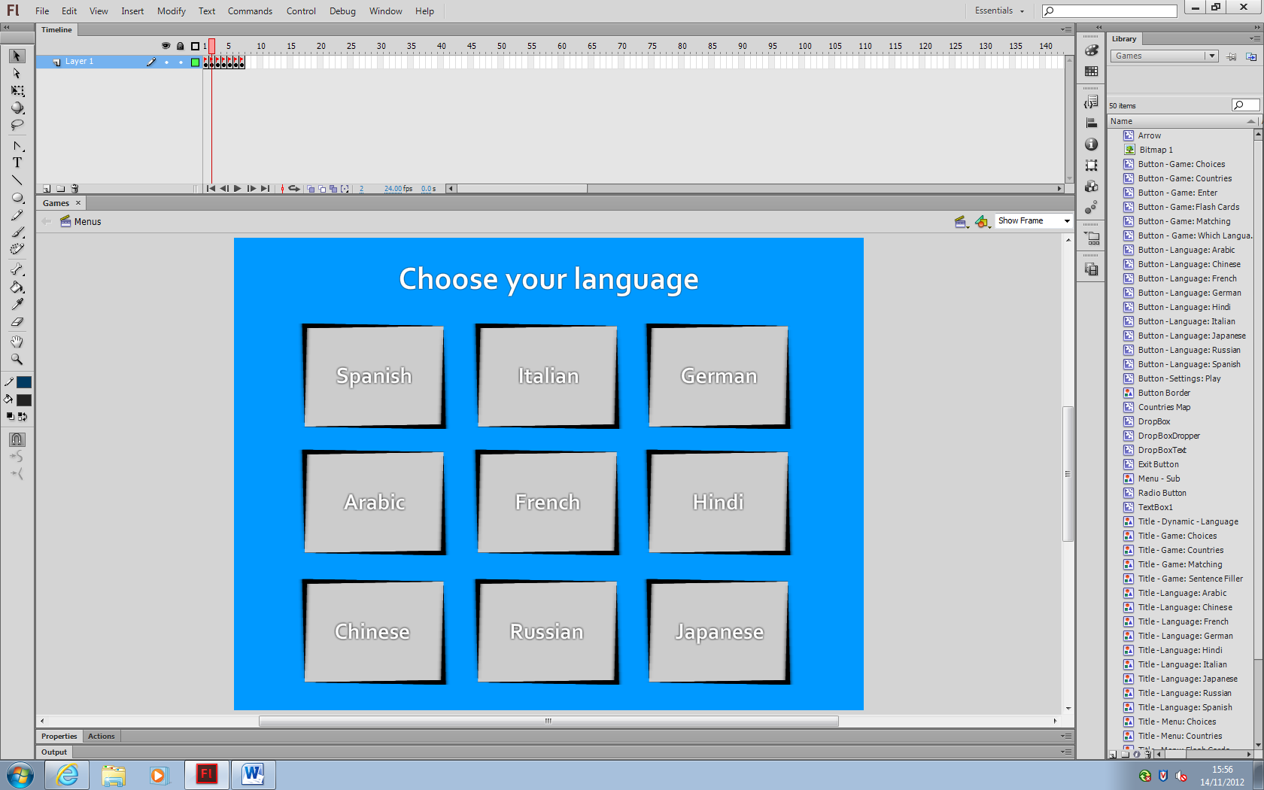

New:

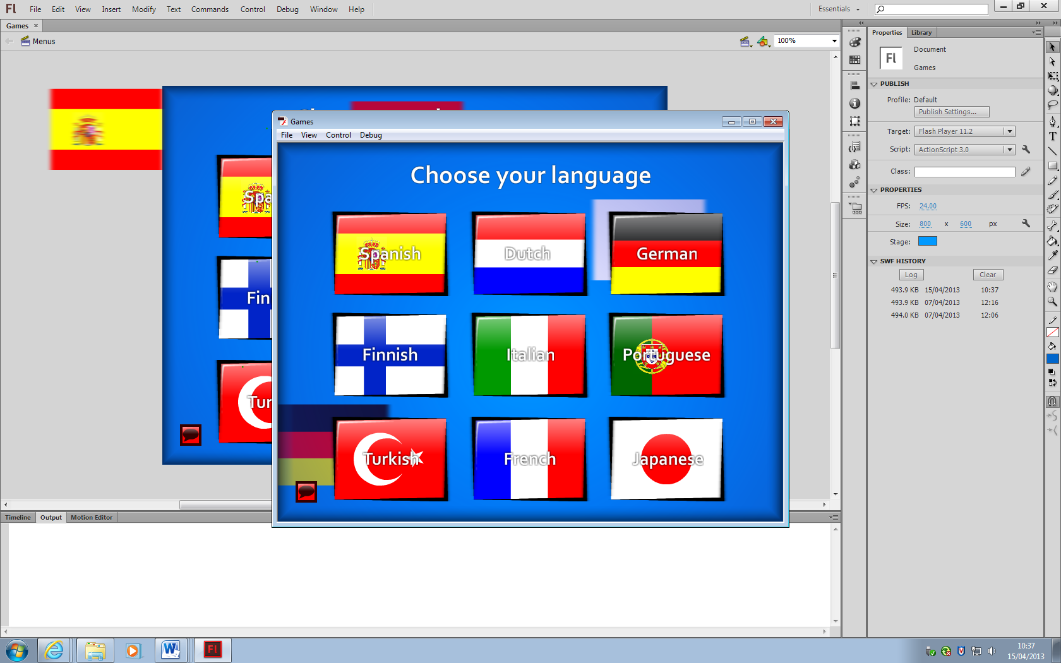

Changes:

I have added backgrounds to each of the language buttons, so that it is easier to identify the main countries that the languages represent. This should also teach which flags belong to which countries (although for languages like Spanish, which are used in a variety of countries, the most popular speaking country’s flag has been used.

**Game Selection Menu**

Original:

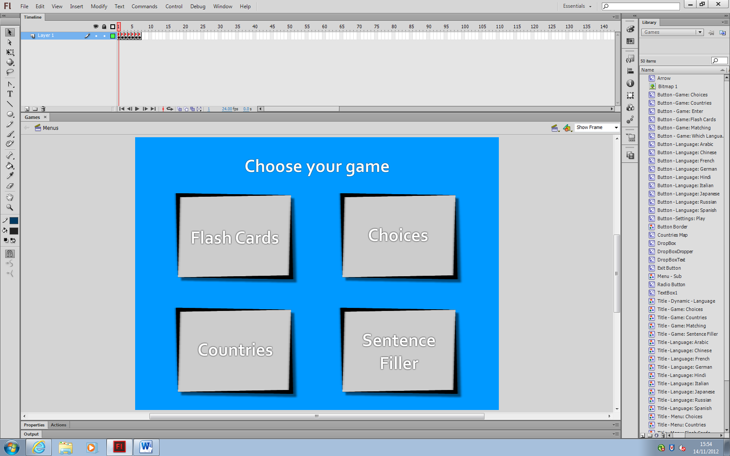

New:

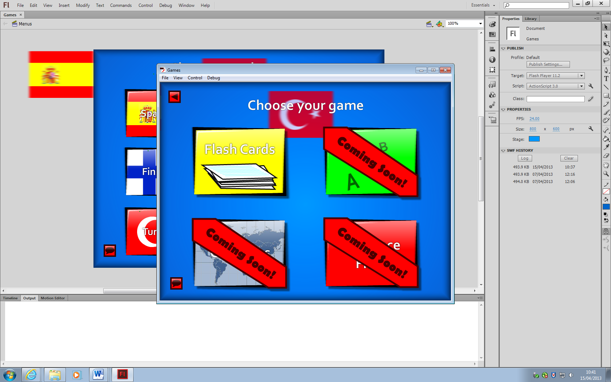

Changes:

Backgrounds have also been added to these buttons, to represent the games that they lead to. Due to time restraints, the development for a few of the games has been postponed. These games have been sectioned off.

**Game Settings Menus**

Original:

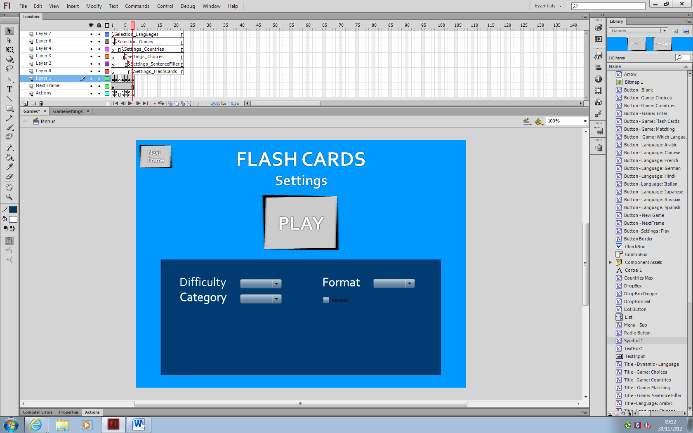

New:

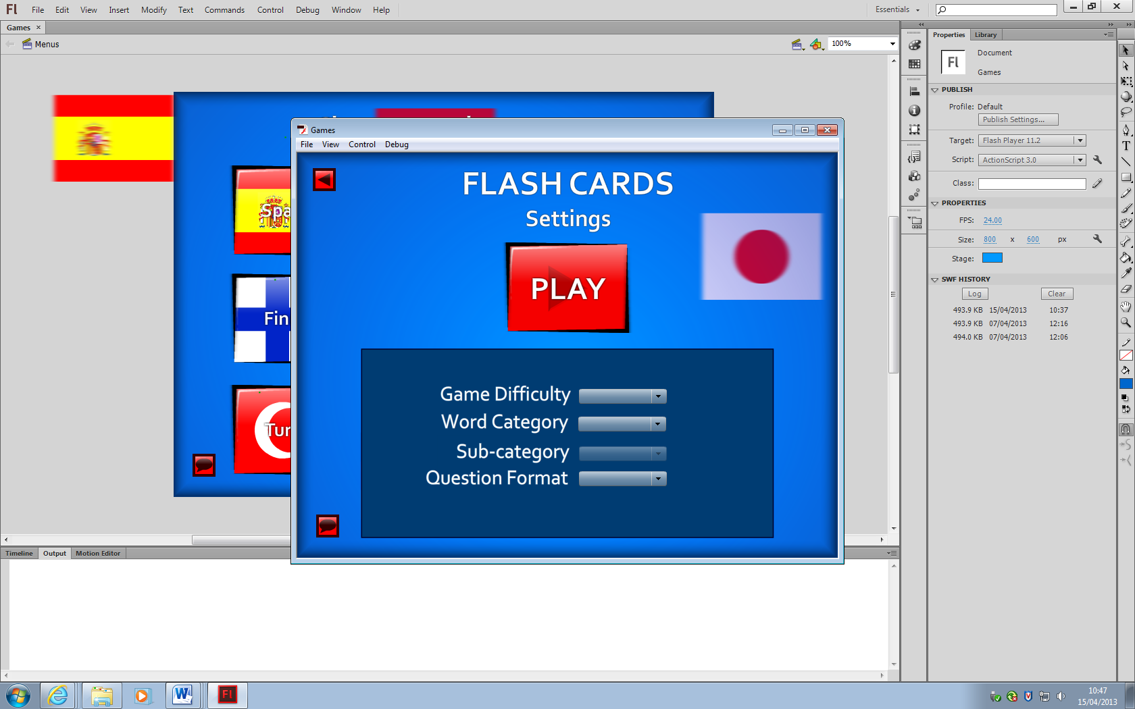

Changes:

**Output design**

**Games Layouts**

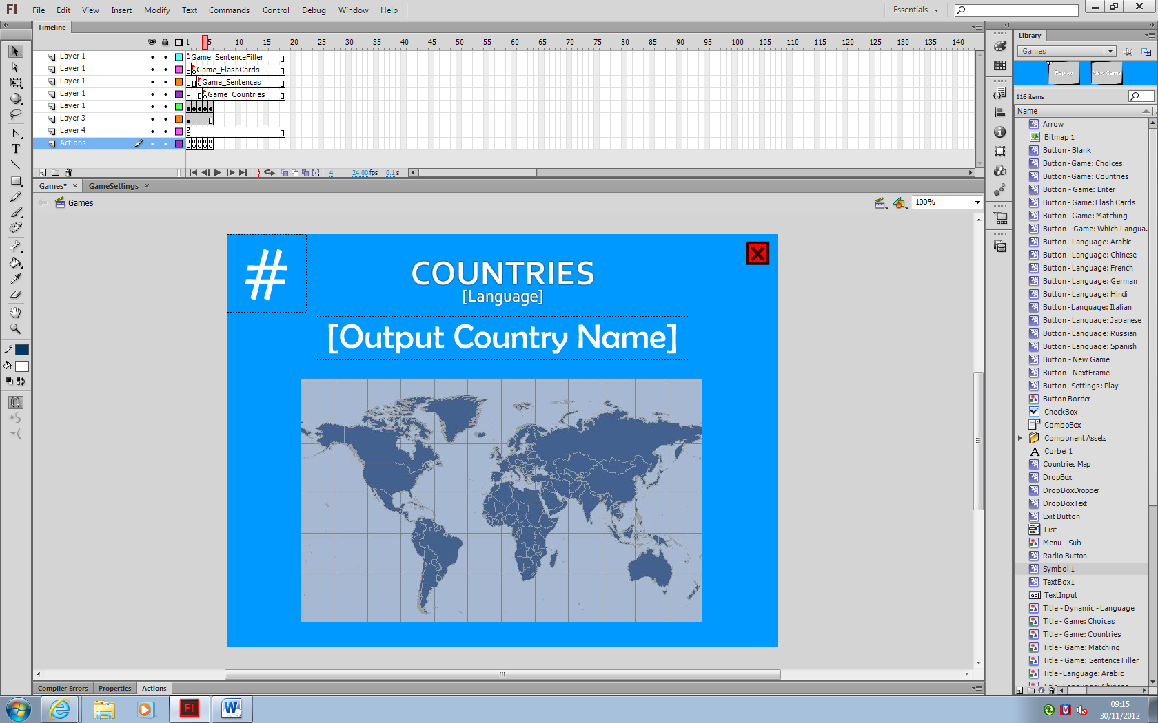

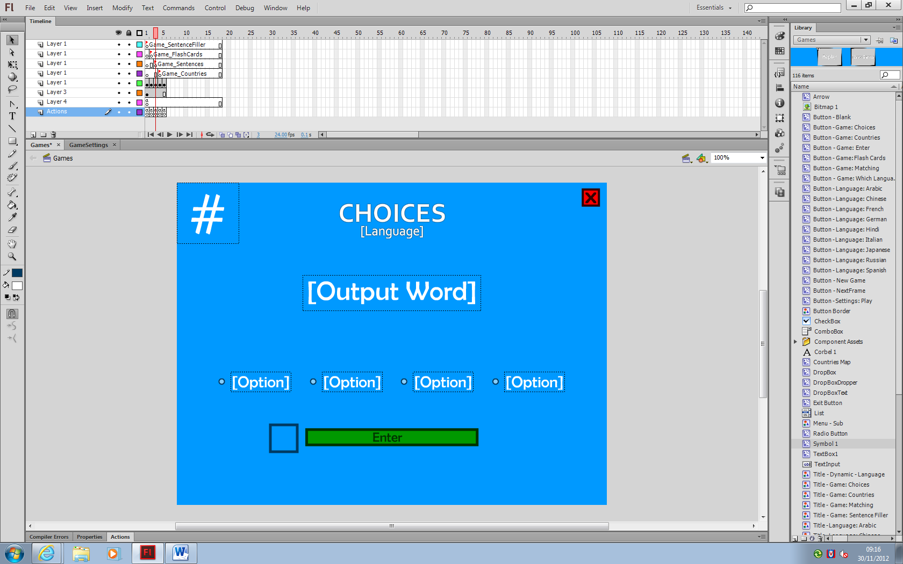

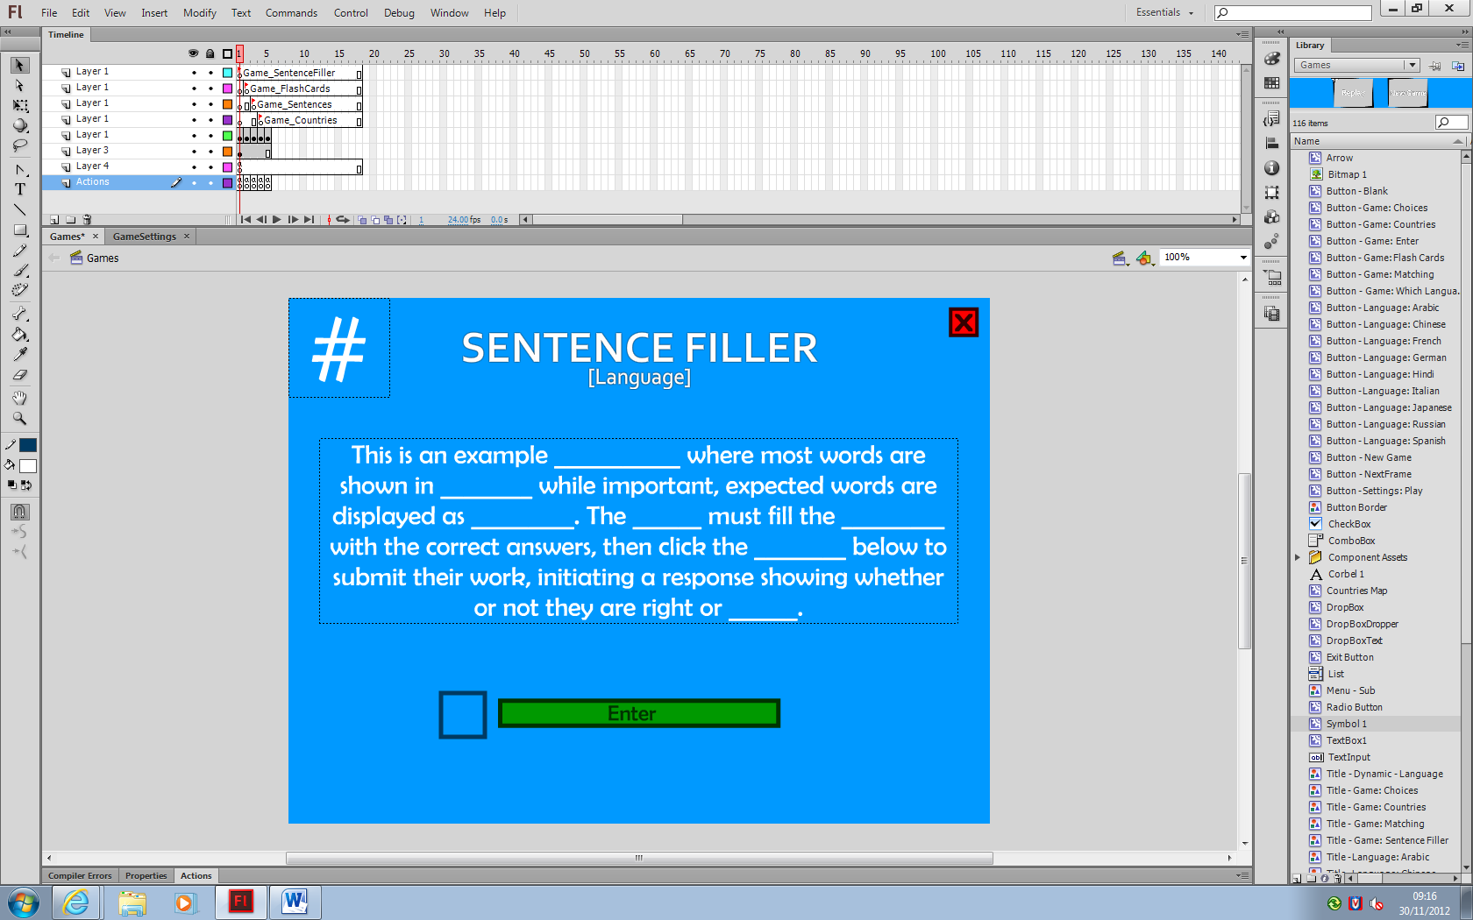

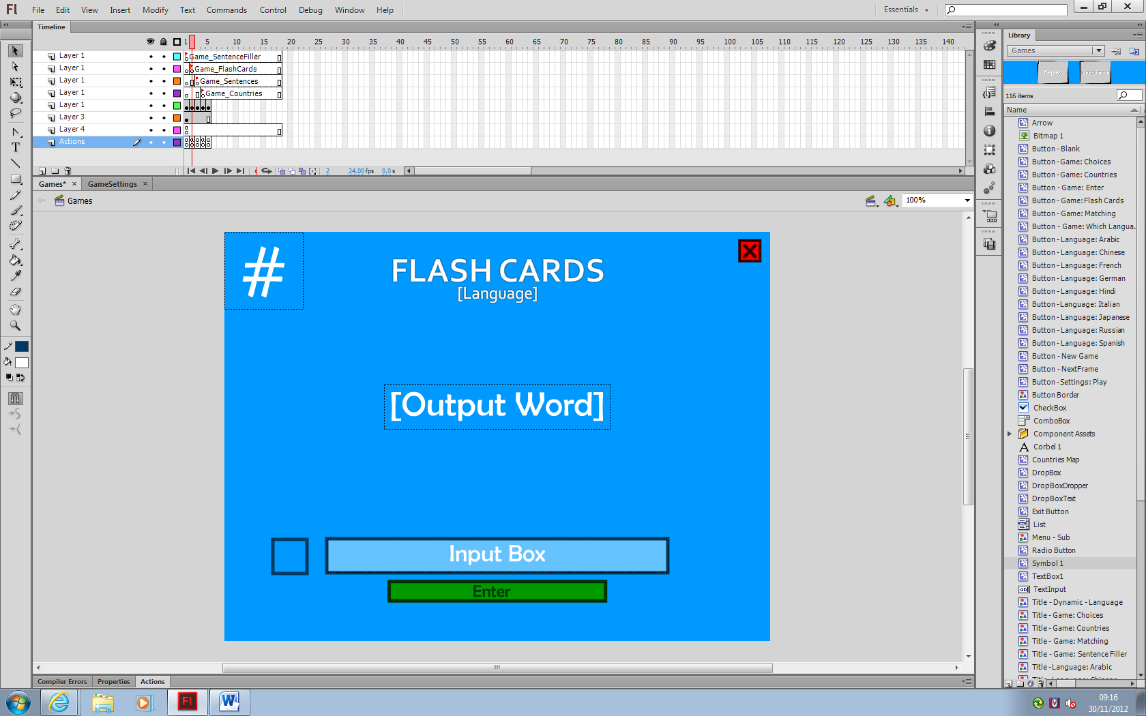

**Score Screen Layout**

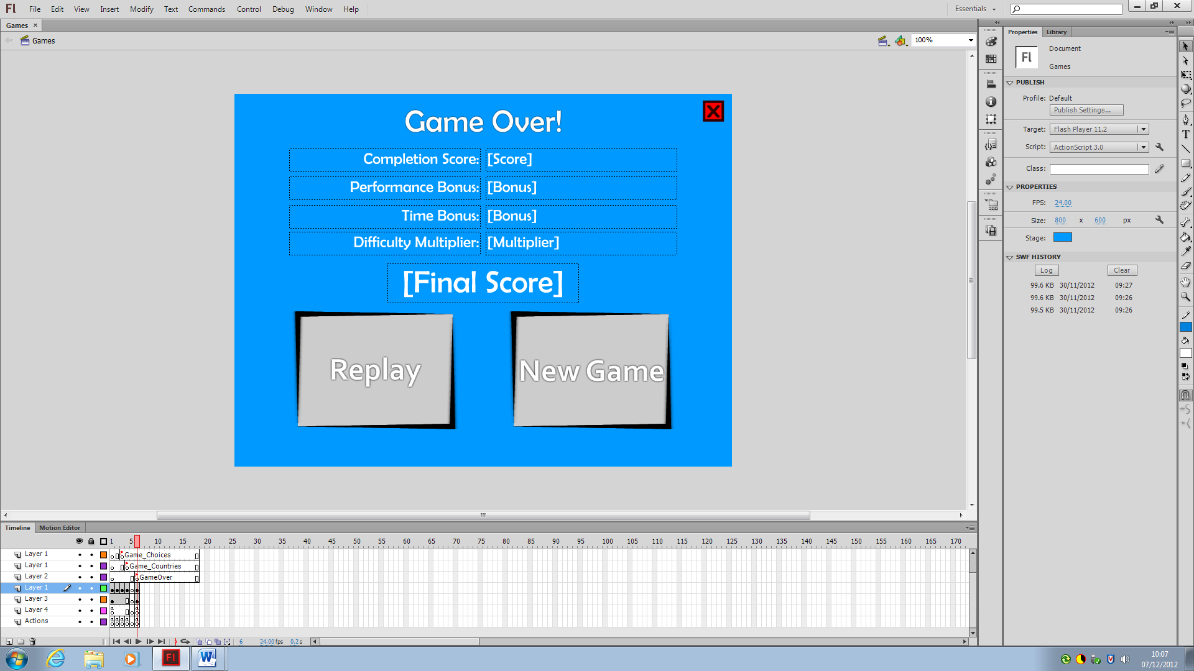

**Pause Menu**

